Project Design Phase-II Technology Stack (Architecture & Stack)

Date |  | 30 September 2026 SWTID-2026-7613
Team ID |  | 30 September 2026 SWTID-2026-7613
Project Name | Auto Ticket Classification using Flow Designer
Maximum Marks | 4 Marks

Technical Architecture:
The Deliverable shall include the architectural diagram as below and the information as per the table1 & table 2
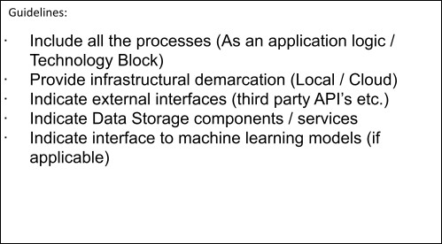
Example: Auto Ticket Classification using Flow Designer (ServiceNow School IT Helpdesk) Reference: https://docs.servicenow.com
5
Technology
IT Helpdesk Staff
Email Notification
Auto Category & Subcategory Assignment
Keyword Analysis
IT HELPDESK
Rule-based keyword classification | No external API or ML model
Description
Component
S.No
6
7
8
Flow Designer
Incident Workflow Table
Student / ServiceNow
Teacher IT Ticket
Form
4
3
2
1
SERVICENOW CLOUD PLATFORM
USER

ServiceNow Ticket/Form Interface
Interface used by students and teachers to create IT support tickets and enter issue details.
User Interface
1.

2. | Application Logic-1 | Automatically analyzes the ticket short description and identifies predefined issue keywords. | ServiceNow Flow Designer
3. | Application Logic-2 | Automatically assigns the appropriate Category and Subcategory based on the identified issue. | Flow Designer If / Else If Conditions and Update Record Actions
4. | Application Logic-3 | Sends an automated email notification to the caller after ticket creation and classification. | ServiceNow Flow Designer Send Email Action
5. | Database | Stores structured IT ticket information including caller, category, subcategory, description, state, assigned group and assigned user. | ServiceNow Incident Workflow / Custom Table
6. | Cloud Database | Not separately used in the project because the solution uses the ServiceNow platform for data storage. | ServiceNow Platform Database
7. | File Storage | Stores project/update-set export files when required for deployment or transfer. | ServiceNow Update Set XML / Local File Storage
8. | External API-1 | No external API is required for the ticket classification process. | Not Used
9. | External API-2 | No external API is required for the ticket classification process. | Not Used
10. | Machine Learning Model | The project uses predefined keyword-based Flow Designer conditions instead of a machine learning model. | Not Used — Rule-Based Classification
11. | Infrastructure (Server / Cloud) | The application is developed and executed within the ServiceNow platform.  Local Server Configuration: Not required Cloud Server Configuration: ServiceNow cloud instance | ServiceNow Cloud Platform

Table-2: Application Characteristics:

S.No | Characteristics | Description | Technology
1. | Open-Source Frameworks | The solution is implemented using ServiceNow Flow Designer and does not depend on external open-source frameworks. | ServiceNow Flow Designer
2. | Security Implementations | Access to ticket information and modification of records should be restricted to authorized users and appropriate ServiceNow roles. | ServiceNow Roles and Access Controls
3. | Scalable Architecture | The solution can be extended by adding new categories, subcategories, keywords, automation rules and additional workflow actions without redesigning the entire system. | ServiceNow Flow Designer
4. | Availability | The solution operates on the ServiceNow platform, allowing users to create and manage IT support tickets through the available ServiceNow environment. | ServiceNow Cloud Platform
5. | Performance | Automatic classification occurs when a ticket is created, reducing manual classification work and improving the efficiency of ticket routing. | ServiceNow Flow Designer Automation

References:
https://c4model.com/
https://developer.ibm.com/patterns/online-order-processing-system-during-pandemic/ https://www.ibm.com/cloud/architecture
https://aws.amazon.com/architecture
https://medium.com/the-internal-startup/how-to-draw-useful-technical-architecture-diagrams-2d20c9fda90d

